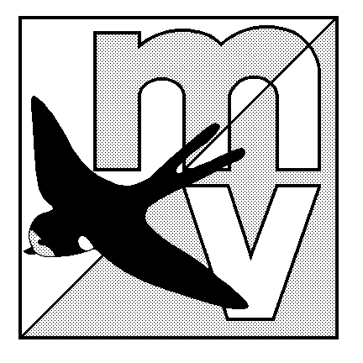
MOLE VALLEY

ORIENTEERING

CLUB

A LOCAL EVENT ON SATURDAY 11th NOVEMBER

AT THE SHEEPLEAS, WEST HORSLEY

CAR PARK grid ref TQ084514. The public car park in Shere Road, West Horsley.

DIRECTIONS Follow Shere Road 1 km SE from the roundabout on the A246 in West Horsley between Leatherhead and Guildford.

REGISTRATION 10.00 - 11.00

START TIMES 10:15 - 11:30

COURSES CLOSE 13:00

COURSES Yellow 2.1km. An easy course for beginners
Orange 2.9 km. A less easy course for more confident beginners.
Green 4.7km. A difficult course for experienced orienteers.

Help and advice will be available for beginners

ENTRY FEES £3 seniors, £1 juniors.

ORGANISER Jon Coles (01737 211983, email: jon.coles@freeuk.com)

